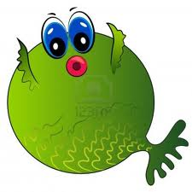
Reminder!

What: Second Grade Musical Performance of “Go Fish”.
When: February 24, 2020 at 6:30 p.m.
- Students need to be in the music room by 6:15.
Where: Lone Star Cafeteria
Costumes: All 2nd grade students need to dress as an ocean animal.
Please remember that you can make your child’s costume as simple or as elaborate as you wish. We have provided some “out of the box” costume suggestions below. You may also buy or make a more traditional fish costume.
Clown fish – Dress like a clown.
Sea horse – Dress in a cowboy hat and boots.
Crabs – Dress in orange/red clothes with antennas sticking out of your head.
Angel fish – Dress in angel wings and a halo.

Blow fish – Stuff a shirt with stuffing and carry an inhaler or tissues.
“Star” fish – Wear a feather boa, tiara or crown, sunglasses, white gloves.
Zebra fish – Dress in zebra stripes.
Tiger shark – Dress in tiger stripes.
Tuna fish – Carry a microphone, could add some music notes and clef signs to costume.
Hammerhead shark – Wear a dorsal fin with a hammer attached to a hat or a tool belt with just hammers. (Toy hammers only.)
Gold fish – Dress in all gold.
Box fish – Wear a cardboard box or pieces of a box.
Dog fish – Dress like a dog.
King fish – Dress like a king!

Attendance: Attendance is required of all students as part of their music & theatre participation grade. Please let one of us know as early as possible if you know your child cannot attend so that alternative arrangements can be made. If your child is ill on the day of the performance, please send a note when your child returns to school.
Questions: Email Mrs. Minyard (Music) jessica.minyard@kellerisd.net or
Mrs. Garner (Theatre) heather.garner@kellerisd.net

Please plan to join us as our second grade students explore the ocean in the musical presentation of…

